Building the PGSuper Application

The source code for the PGSuper prestressed bridge beam design & analysis program is available for download from the Washington State DOT web site, or preferably from WSDOT’s CVS server.

When downloaded to a system other than the original development environment, the source code out of the box will not successfully build a program capable of running due to a number of reasons. One reason is the dependency of the application on a third party software product for a custom graphic user interface dialog control item. The proprietary code cannot be redistributed along with the open source application source code.

The product as currently used by the application is out of date, during which time the product has changed and evolved and the company responsible for the product has been bought and sold.

The application build procedure must be automated in order to force consistency on the process and the product. But of course, in order to automate the procedure, it is first necessary to define and describe the procedure in detail. And the procedure must be complete so that it will work on any target workstation to be used as a development environment. Such an automated procedure and/or procedure document is also required for disaster recovery.

Installation/Setup of development environment (done once: automation would be helpful)
1. Get source code from WSDOT.
2. Install HTML Help Workshop
3. Install & build Objective Grid
4. Establish System environment variables
5. Establish Developer Studio environment variables
6. Additional Developer Studio settings.
7. Install DLL Registration tools
8. Perform Installation into Windows

Build the application (done as often as needed: automation should be mandatory)
1. Ensure DevStudio configuration type
2. Run CleanALL.bat to initialize
3. Enter the WBFL workspace using Developer Studio
4. Run the Developer Studio Batch build procedure
5. Register the resulting WBFL libraries
6. Save the WBFL workspace
7. Enter the PGSuper workspace using Developer Studio
8. Run the Developer Studio Batch build procedure
9. Register the resulting PGSuper libraries
10.Save the PGSuper workspace

Installation/Setup of Development Environment (done once)

1. Get source code from WSDOT

Get the Source Code from WSDOT. Current code for PGSuper and the Washington Bridge Foundation Libraries applications came from the WSDOT ftp sites:

ftp://ftp.wsdot.wa.gov/public/Bridge/Software/Files/Install_PGSuper_Source_1.6.0.exe
ftp://ftp.wsdot.wa.gov/public/Bridge/Software/Files/Install_WBFL_Source_2.3.0.exe

The most current source code can be obtained from WSDOT’s CVS server using the following settings:

- Protocol SSL (:sserver:)
- Server cvs.wsdot.wa.gov
- Repository Folder /Production
- Module PGSuper, WBFL
- Username TxDOT
- Password guest

These installation sets were created with conditional coding based on the existence of the user defined macro NOGRID. If NOGRID is defined, no references to Objective Grid will be visible to the
Compiler / Linker. The current build had NOGRID defined to prevent the inclusion of any code that references the Objective Grid software.

The source consists of two separate installation sets, WBFL and PGSuper. WBFL (Washington Bridge Foundation Library) consists of underlying class libraries and resources for the PGSuper application as well as for other applications. PGSuper contains source for creating the Library Editor and PGSuper dlls and executables.

For this procedure description, the source will be installed under the folder: D:\arp.
The top-level subfolders beneath arp must be: wbfl, pgsuper, lib, and OGLite.

2. Install HTML Help Workshop

Download and install HTML Help Workshop:http://msdn.microsoft.com/library/default.asp?url=/library/en-us/htmlhelp/html/hwMicroSoftHTMLHelpDownloads.asp

3. Install and build OGLite

This is the proprietary 3rd party software required for the build. WsDOT currently uses an outdated version of OGLite. This old version is no longer available and the company that made it has been sold and reorganized.

At this time; however, all references to the OGLite code are not all switched on./off by the NOGRID preprocessor macro definition. Therefore, at this time even when NOGRID is defined, the folder: OGLite must exist and be populated with a few specific header files. OGLite must contain the subfolders: include and lib. The include folder must contain the header files: gxall.h, gxres.rc, gxresrc.h. [I did get these from the source code for the current version of Objective Grid, and luckily there were no problems that prevented compilation. –I’ve fixed these problems in the latest source code]

4. System environment variable settings

Some operating system environment variables must be set via START->CONTROL_PANEL->ADVANCED->ENVIRONMENT_VARIABLES. These are:

Include = D:\Program Files\Microsoft Visual Studio\VC98\atl\include;D:\Program Files\Microsoft Visual Studio\VC98\mfc\include;D:\Program Files\Microsoft Visual Studio\VC98\include;d:\arp\oglite\include;
d:\arp\pgsuper\include;d:\arp\wbfl\include;D:\Program Files\Microsoft SDK\include

Lib = D:\Program Files\Microsoft Visual Studio\VC98\mfc\lib;D:\Program Files\Microsoft Visual Studio\VC98\lib;d:\arp\lib;d:\arp\oglite\lib;d:\arp\pgsuper\lib;d:\arp\wbfl\dmanip\release;
D:\Program Files\Microsoft SDK\lib

Path=D:\Program Files\Microsoft Visual Studio\Common\Tools\WinNT;D:\Program Files\Microsoft Visual Studio\Common\MSDev98\Bin;D:\Program Files\Microsoft Visual Studio\Common\Tools;D:\Program Files\Microsoft Visual Studio\VC98\bin;d:\arp\lib;d:\arp\wbfl;d:\arp\pgsuper;d:\arp\pgsuper\lib

MSDevDir= D:\Program Files\Microsoft Visual Studio\Common\MSDev98

5. Developer Studio environment variable settings

Several Developer Studio environment variables must be set via TOOLS->OPTIONS->DIRECTORIES.
These are: (Ignore files shown in red – these are for the Digital Fortran product from Digital/Compaq/HP)

INCLUDE FILES:
D:\Program Files\MicroSoft Visual Studio\DF98\IMSL\Include
D:\Program Files\Microsoft Visual Studio\VC98\Include
D:\Program Files\Microsoft Visual Studio\DF98\Include
D:\Program Files\Microsoft Visual Studio\VC98\MFC\INCLUDE
D:\Program Files\Microsoft Visual Studio\VC98\ATL
D:\Program Files\Microsoft Visual Studio\VC98\ATL\Include
D:\Program Files\HTML Help Workshop\include
D:\arp\oglite\include
D:\arp\pgsuper\include
D:\arp\wbfl\include

EXECUTABLE FILES:
D:\Program Files\Microsoft Visual Studio\Common\Tools
D:\Program Files\Microsoft Visual Studio\VC98\BIN
D:\Program Files\Microsoft Visual Studio\DF98\BIN
D:\Program Files\Microsoft Visual Studio\Common\Msdev98\BIN
D:\Program Files\Microsoft Visual Studio\Common\TOOLS\WINNT
D:\WINDOWS\system32
D:\WINDOWS
D:\arp\lib

LIBRARY FILES:
D:\Program Files\Microsoft Visual Studio\DF98\IMSL\Lib
D:\Program Files\Microsoft Visual Studio\VC98\Lib
D:\Program Files\Microsoft Visual Studio\DF98\Lib
D:\Program Files\Microsoft Visual Studio\VC98\MFC\LIB
D:\arp\lib
D:\arp\oglite\lib
D:\arp\pgsuper\lib
D:\arp\wbfl\dmanip\release
D:\Program Files\HTML Help Workshop\lib

SOURCE FILES:
D:\Program Files\Microsoft Visual Studio\VC98\MFC\SRC
D:\Program Files\Microsoft Visual Studio\VC98\MFC\INCLUDE
D:\Program Files\Microsoft Visual Studio\VC98\ATL\INCLUDE
D:\Program Files\Microsoft Visual Studio\VC98\CRT\SRC

The current PGSuper code honors a macro named NOGRID. This macro can be defined via PROJECT->SETTINGS->C/C++ . If defined, the source code is compiled and linked ignoring all references to the OGLite class methods. If NOGRID is defined, then all references to the OGLite class methods will be compiled and linked.

6. Additional Developer Studio settings

It may be necessary to increase the maximum heap space allocation settings for some of the projects. This is done via PROJECT->SETTINGS->C++->PREPROCESSOR_DEFINITIONS. The value for Beams.dll needs to be around 500 … “/Zm500 /c”.

7. Install DLL Registration tools

The registration tools are not currently included in the downloaded installation set. Given a copy of the DevStudio customized macro file: mymacros.dsm, it must be placed in the folder: D:\Program Files\Microsoft Visual Studio\Common\.

A custom tool must be created to support the registration macros. In the Developer Studio environment select Tools->Customize. On the Tools tab create tool as shown below. This must be the 8th tool in the list. If not, change the string “UserTool8” in the OLERegister macro to reflect the position of the tool.
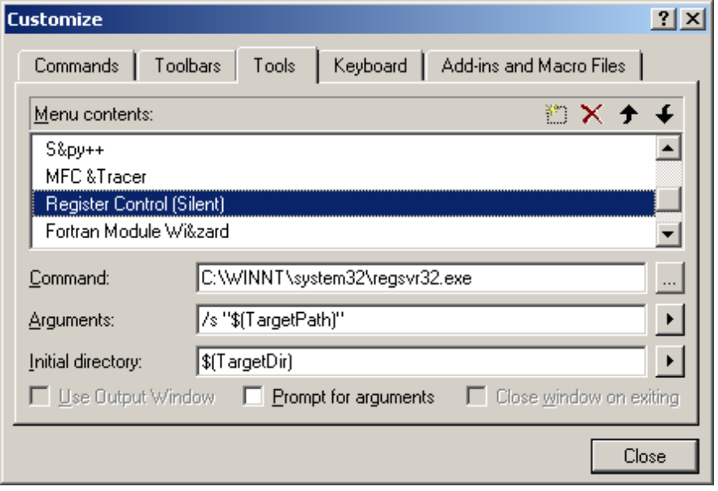

TIP: To test that the macros and tools are configured properly, temporarily replace the /s argument for the custom tool with /v and run the OLERegister macro. This should produce several OLE/COM registration confirmation dialogs (not all will be success messages). If the OLERegister macro is working properly, restore the /s argument

The purpose of these macros is to perform OLE/COM registration of the various WBFL and PGSuper components.

The macro referenced is OLERegister. It is called with the desired configuration mode ‘debug’ or ‘release’.
For convenience, two tool buttons should be created to call this macro for either ‘debug’ or ‘release’.

8. Perform Installation into Windows

The registration info was installed into Windows by an earlier install of the WSDOT PGSuper Product.
At this time ... we can just update the registry for our local build by either editing the registry with RegEdit or by going to FILE->PROGRAM_SETTINGS->FILE_LOCATIONS from the locally built executable and performing the appropriate changes:

User Templates Folder: D:\arp\PGSuper\Templates
Workgroup Templates Folder: D:\arp\PGSuper\Templates
Master Library File: D:\arp\PGSuper\PGSuper.lbr
Tip of the Day: D:\arp\PGSuper\PGSuper.tip

However, we should be able to perform the registry setup outside of the new product install … in order to ‘set up’ the registry for a development environment.

Build the application (done as often as needed)

1. Ensure DevStudio configuration type

Make sure that all code is to be compiled using the same configuration mode. ‘Debug’ and
‘Release’ cannot be mixed together … this will cause runtime problems. The configuration mode is set via
BUILD->SET ACTIVE CONFIGURATION or the Active Configuration combo box on the Build toolbar.

2. Run ClearALL.bat to initialize

Run the bat file: clearALL to destroy all existing objects and other temporary files to ensure no problems occur due to caching or persistence. There are a few object files that must be handled manually (ending in _i.c) that are skipped by this procedure (I’ve renamed these two problematic files to *_clsid.cpp to make it clear that they are hand coded files and to prevent them from being deleted by the automated procedure. They are in CVS).

NOTE: This bat file does not come with the download. The download contains clearWBFL.bat, which must be modified before using … as it will wipe out some files that need to persist. (See note above.)

3. Enter the WBFL workspace using Developer Studio

The file: wbfl.dsw is delivered with the download in the WBFL folder. Open this file with Developer Studio to enter the WBFL workspace.

4. Run the Developer Studio BUILD->BATCH BUILD procedure

Pick ‘Batch Build’ from the Build selection on the menu bar. Go through the list of check boxes in the list box that displays, and select all the items Pressing the ‘Build’ button will start the batch build procedure.

Once the build is complete, register either the Debug or Release versions of the DLL’s so they aren’t mixed at runtime.

5. Register the resulting WBFL libraries

Push the appropriate tool button for either ‘debug’ or ‘release’ for the configuration being built. The macro processes all dlls created … which are both regular C++ dlls and COM dlls. Only the COM dlls are registered, while the regular C++ dlls are left alone (registration is attempted on the regular C++ dll’s, static libs, and executable unit test drivers and, as expected, will fail. The OLERegister macro uses a brute force approach). The command behind the tool buttons normally has ‘\s’ as an option, for ‘silent’. However, the ‘\v’ option for verbose, will show the status dialogs.

6. Save the WBFL workspace

Save all changes/updates to the WBFL workspace before leaving to enter the PGSuper workspace.

7. Enter the PGSuper workspace using Developer Studio

The file: pgsuper.dsw is delivered with the download in the PGSuper folder. Open this file with Developer Studio to enter the PGSuper workspace.

8. Run the Developer Studio BUILD->BATCH BUILD procedure

Pick ‘Batch Build’ from the Build selection on the menu bar. Go through the list of check boxes in the list box that displays, and select all of the items.

Once the build is complete, register either the Debug or Release versions of the DLL’s so they aren’t mixed at runtime. Make certain this registration is consistent with the registration done for WBFL.

9. Register the resulting PGSuper libraries

Push the appropriate tool button for either ‘debug’ or ‘release’ for the configuration being built. The macro processes all dlls created … which are both regular C++ dlls and COM dlls. Only the COM dlls are registered, while the regular C++ dlls are left alone (registration is attempted on the regular C++ dll’s, static libs, and executable unit test drivers and, as expected, will fail. The OLERegister macro uses a brute force approach). The command behind the tool buttons normally has ‘\s’ as an option, for ‘silent’. However, the ‘\v’ option for verbose, will show the status dialogs.

